Standard Operating Procedure

1. Purpose
How to properly parallel the Anilox roller in a print section. This procedure can be used on any print section on the machine. This will help you parallel the Anilox roll and make sure that you are getting pressure evenly across the entire section.

2. Scope
This is to be used by Thacker Machinery/SRPACK employees and/or any personnel that need the proper way to parallel and ZERO the Anilox roll on the print section on their machine.

3. Prerequisites
Tools Needed: 7.2 MM Gauge, 24MM Wrench or Crescent Wrench. (Some printers use a .250 print plate or smaller, use this number as a gauge)
Machine must be opened and not currently running. Machine must have power and air in order for the Anilox roller to engage.

4. Procedure
- Open the machine to the desired print section and open it with the side that has access to the Anilox roll. On a bottom printer section unit, the is usually located on the backside of the section.
- Release the two latches on either side of the Anilox Roll guard and open this guard.
- Make sure that the cylinder is clean across the portion that you will be gauging so that your gauge sits flat against the surface.
- Go to the operator side LCD screen and MANUALLY ENGAGE the Anilox Roll. This will push the Anilox Roll up towards the Print Cylinder.
- Take your gauge and push it between the Anilox Roll and the Print Cylinder. Go to the operator side LCD screen and use the Anilox Gap Switch to raise or lower the gap until you bring the Anilox Roll and Print Cylinder flat against the 7.2mm Gauge. Make sure that you check at least 5 locations across the Anilox Roll and the Print Cylinder gap.
- There are 2 screws that control this parallel. You must unscrew the nut on the screw to loosen it and then either move it upward or downward if needed to parallel the gap or to allow for more room to get to ZERO if need be. These are your Parallel Adjustment Screws.
- Once all 5 locations that you have gauged are flat and squeezing between the Anilox Roll and the Print Cylinder firmly Go to the Operator side LCD screen and tap on the Anilox Gap on the touchscreen itself, this will trigger the PASSWORD screen. PASSWORD is 12345.
- The Anilox Gap will show again but it will be highlighted in BLUE this time. Touch it again. This will trigger the screen where you can input your gap now.
- Enter in 0.000 and hit enter. This should change your Anilox Gap to ZERO. It will still be highlighted in Blue.
- Hit F1 on the Touchscreen, this takes you to the main page of the LCD touchscreen and out of the password protected area. You are done.

5. Definitions and Pictures
Anilox Roll- An anilox roll is a hard cylinder, usually constructed of a steel or aluminum core which is coated by an industrial ceramic, typically chromium (III) oxide powder, whose surface is engraved with millions of very fine dimples, known as anilox cells. In the printing process, the anilox roll is coated in a precise layer of ink that is then transferred to the raised portions of the printing plate. The number, size, and geometry of the anilox cells vary and will determine the amount of ink that the anilox roll delivers to the plate | 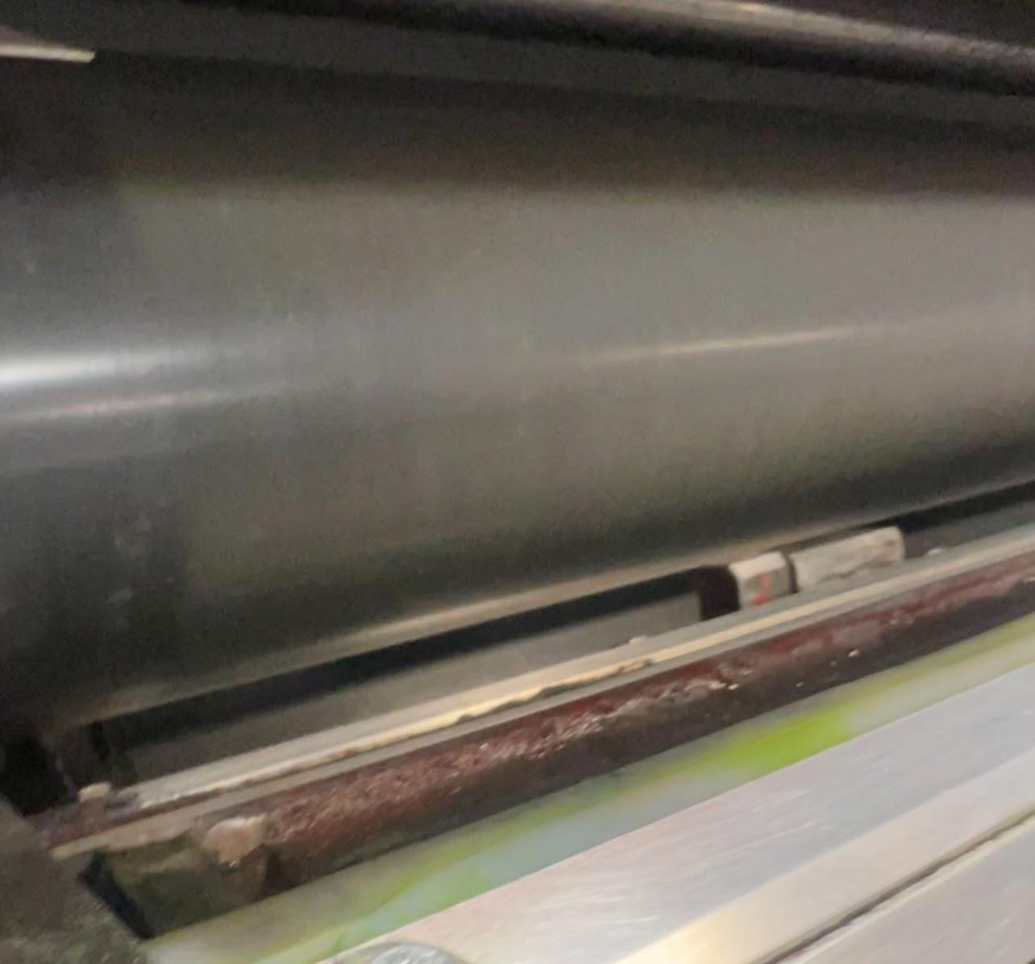
Print Plate Cylinder- the cylinder of a rotary printing press that carries the print plate and impresses it by counterrotation against the inked printing surface on the plate cylinder. | 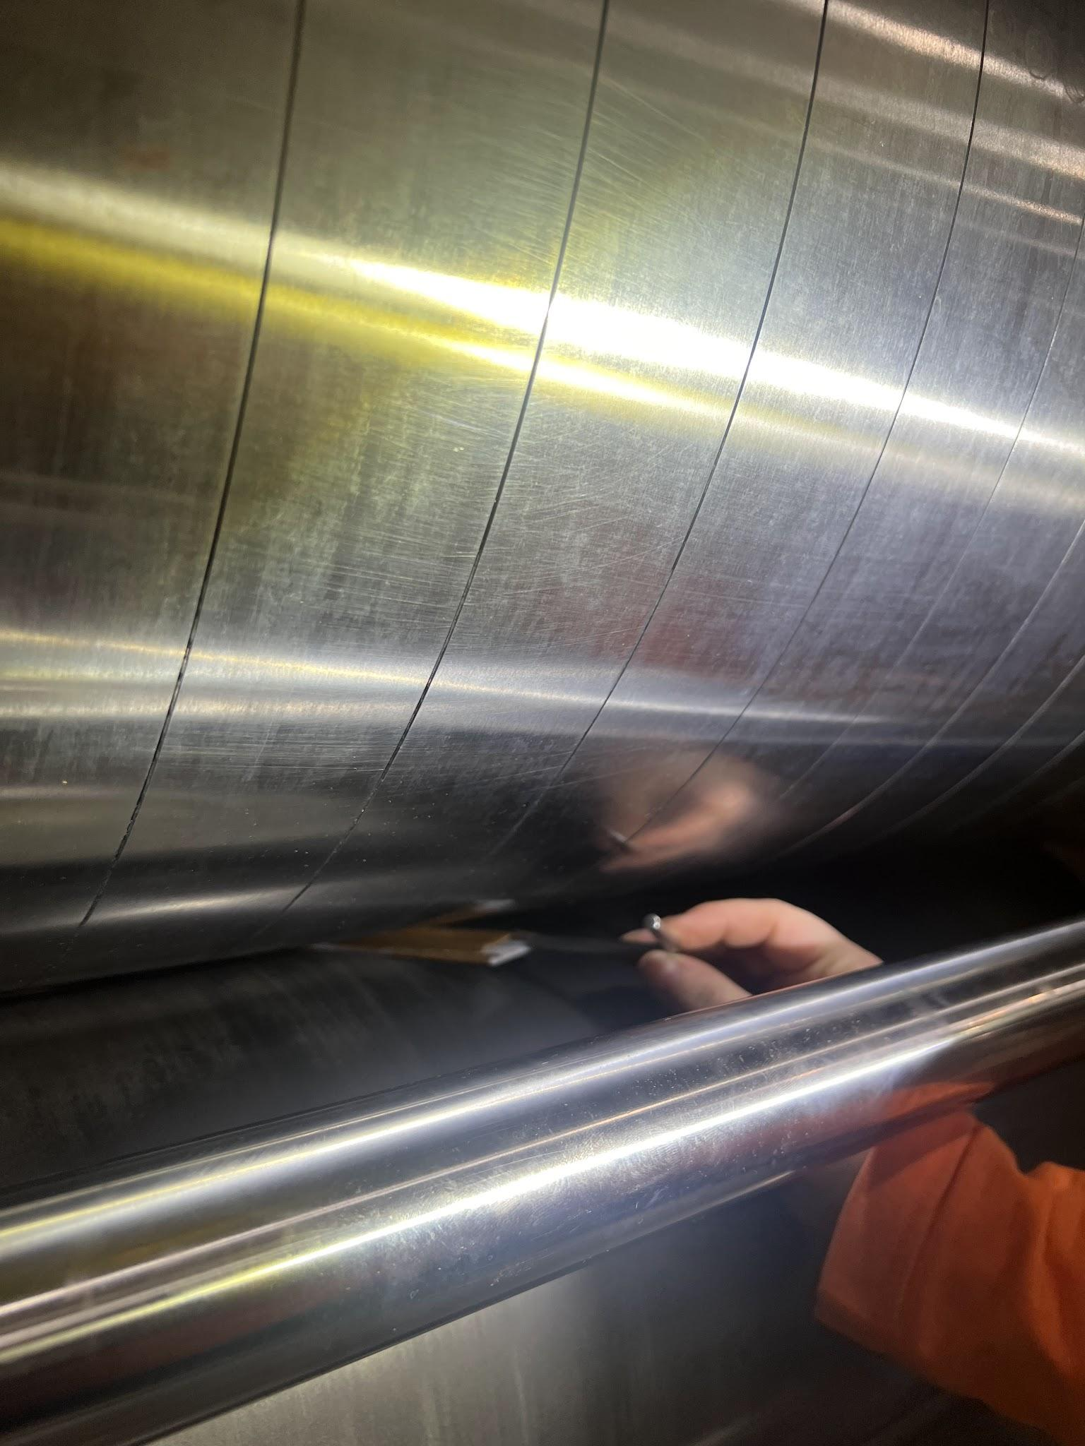
Anilox Gap- The gap between the Anilox Roll and the Print Plate Cylinder | See Above Picture - The gauge being used is place between the Anilox Gap
Anilox Engage - When you engage the Anilox you are telling the print station that you want to use that printer to print and you are engaging the Anilox roll to come forward towards the Print Plate Cylinder. | 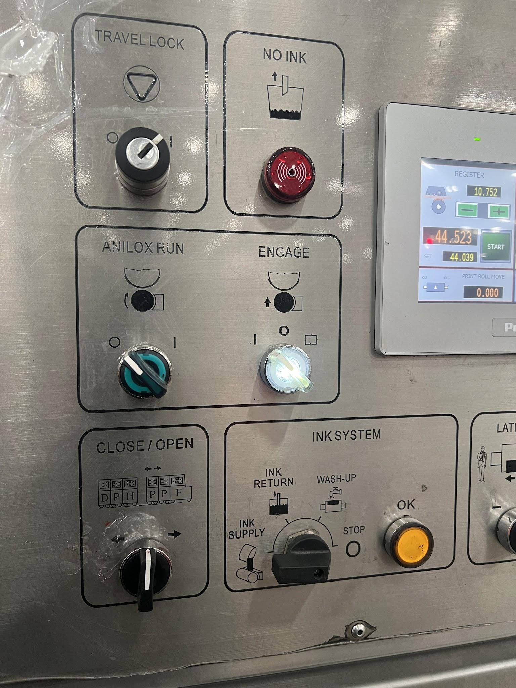
Anilox Roll Parallel Screws- These screws control the parallel of the Anilox Roll. There is 1 located on each side of the anilox roll. | 