Standard Operating Procedure

1. Purpose
How to Zero out the counter ejectors MAIN 3 processes which are Fork UP/Down, Fork In/Out, and Elevator Up/Down. This procedure can be used on different errors you may get in the counter ejector along with Zeroing out this entire section. This will provide smooth movement in that area, extend your machine life, and decrease downtime for costly repairs.

2. Scope
This is to be used by Thacker Machinery/SRPACK employees and/or any personnel that need the proper way to Zero out the counter ejectors MAIN 3 processes which are Fork UP/Down, Fork In/Out, and Elevator Up/Down.

3. Prerequisites
Tools Needed: There are a lot of moving parts in the counter ejector so you may need some tools beforehand if you are doing other work in this area such as tightening up the chains or adjusting the cylinders BUT for this step you do not need any actual tools. You can have some allen keys onhand in case you need to move any sensors.

4. Procedure.

- Turn the switch on the Counter Ejector to Manual so that you can move the controls on the HDI screen.
- Hit F3 on the HDI screen and there you can move forks and tables that are in the counter ejector. OR
- Hit the switch on the Counter Ejector, You can move these positions with the new buttons on the backside of the counter ejector.
- First measure the backstop and make sure this number is correct on the L2 screen of the HMI screen. This number must be correct because it is the starting point of the FORKS IN AND OUT dimensions. Calibrate this number if it is not correct.
- Now measure the paper fork in by the distance between the pusher wall and the fork in.
- Go to the HMI screen and touch the upper right tab next to the F1 location and this should open up a password screen. The password is 13572468
- Next hit the Servo Position tab. This will take you to the 3 critical servo positions in the counter ejector. The fork up and down, fork in and out, and finally lifter (elevator) up and down.
- Hit the Wrench on a hard hat icon. Hit this button. This will now ask if you want to reset these locations with a push of the button to zero. Type in the FORK IN dimension that you measured and hit okay. This will put that number in this location.
- Now move the Paper Fork to the up position manually making sure that you light up the proximity switch and it does not go past this and hit the limit switch.
- Now go to the PASSWORD screen and return to the SERVO POSITION tab. You will be working with the Fork up and Down this time. Hit the Hard hat icon and then hit okay. This will Zero out the fork up and down position.
- The last position to home is the elevator up and down. To do this you need to calibrate the press table and make sure this location is correct. 350MM is a good bottom location of the table to home it to.
- Now manually lower the TABLE or ELEVATOR to the proximity switch making sure that you do not go past this location and hit the limit switch.
- Now go to the PASSWORD screen and return to the SERVIO POSITION tab. You will be working with the Elevator up and down position this time. Hit the Hard hat icon and then hit okay. This will Zero out the fork up and down position
- Back out of this screen. You can manually move anything at this point or set it in automatic and it should go through and set itself back home.

IF your machine times out on a limit switch, You have to completely remove the limit switch, then go to the computer and hit the alarm reset on the STATUS SCREEN. Next go to the Counter Ejector back section and put the counter ejector into MANUAL. Hit the Blue HOME button several times to reset. Flip to Automatic and then back to manual and now you can manually move it away from the limit switch and off the sensor. (this limit switch process applies to all three sections) make sure the sensor is close (almost touching) and secure. Ensure that your top height of the elevator is low enough that the belts take your corrugated out of the area.

5. Definitions and Pictures
Proximity Sensor- The sensor that is located to detect when the forks reached its 0 limit back, 0 limit high, and the elevator 0 limit low. Those are the 3 Proximity sensors that we are speaking about in this section.
Limit Switch - Located just after the Proximity Sensors and will go off if fully engaged. You must remove the KEY located on the counter ejector operator side for 30 seconds after removing the switch physically. When you power the machine back on, you should be able to move the position manually again. Remember to reattach the limit switch if this happens.

PICTURES:
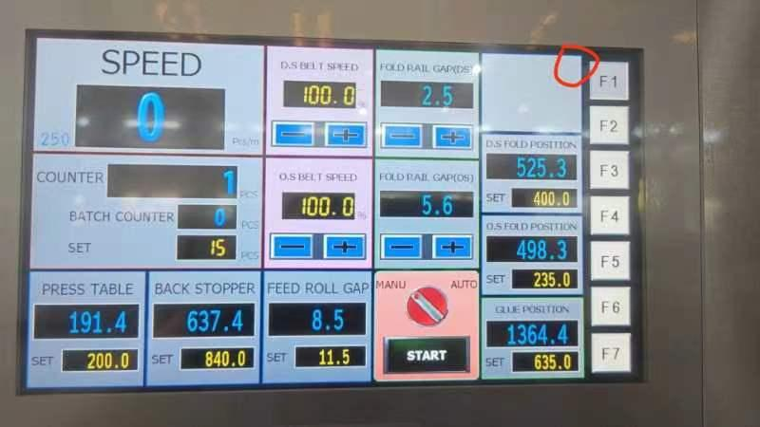
This is where you need to touch in order to access the password screen that you need to get to the proper spot so you can zero out and home your counter ejector. Touch between the F1 tab and the empty tab space next to it. Right in the middle of them both will take you to the password screen.

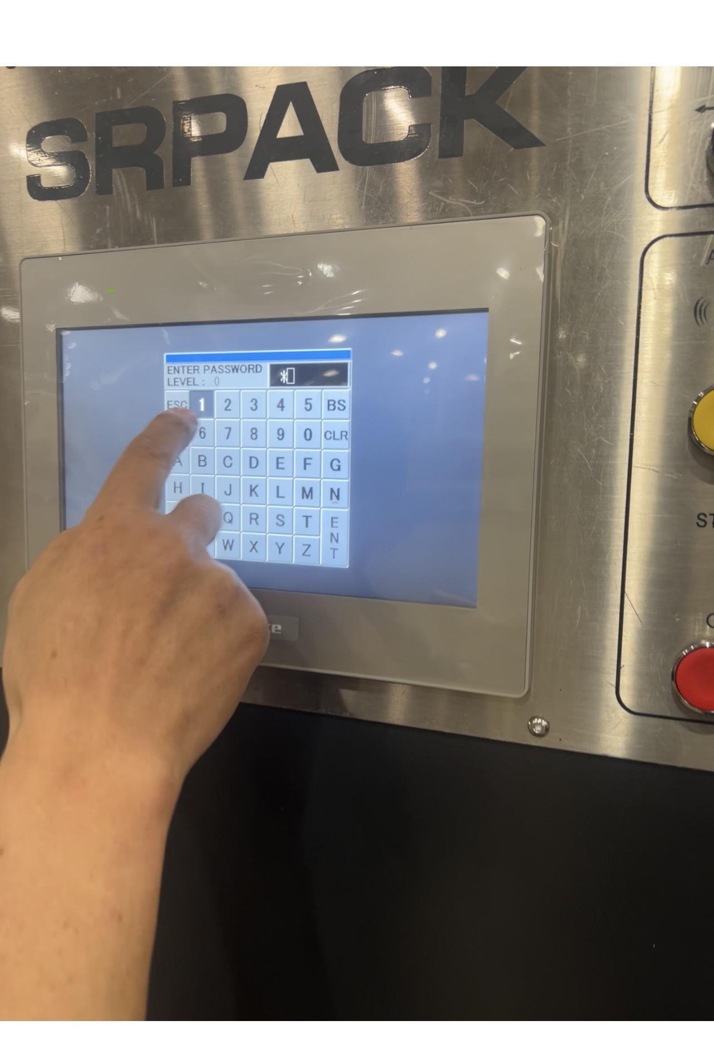
The PASSWORD is 13572468
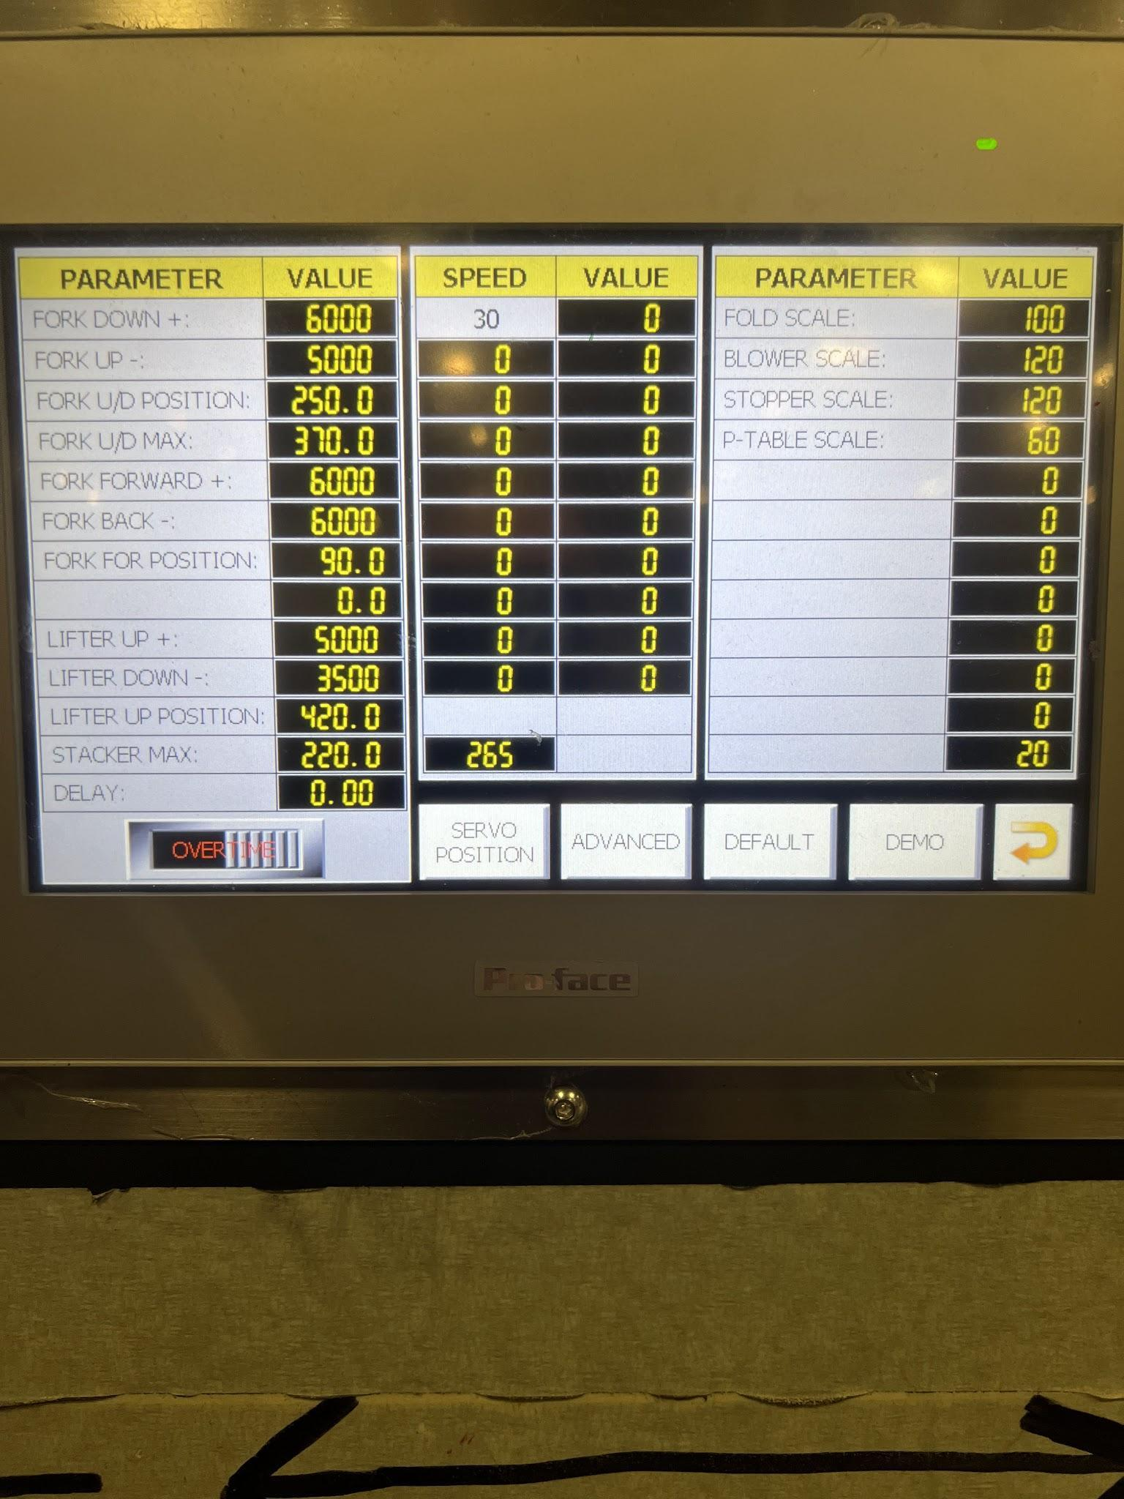
After putting in the password it will take you to this screen. This is the screen where you Hit the SERVO POSITION TAB.
NOTE this screen. When you get everything all set up and recalibrated, you can start the machine at any speed and come back here and hit the demo tab, this will cycle the counter ejector according to the speed automatically.
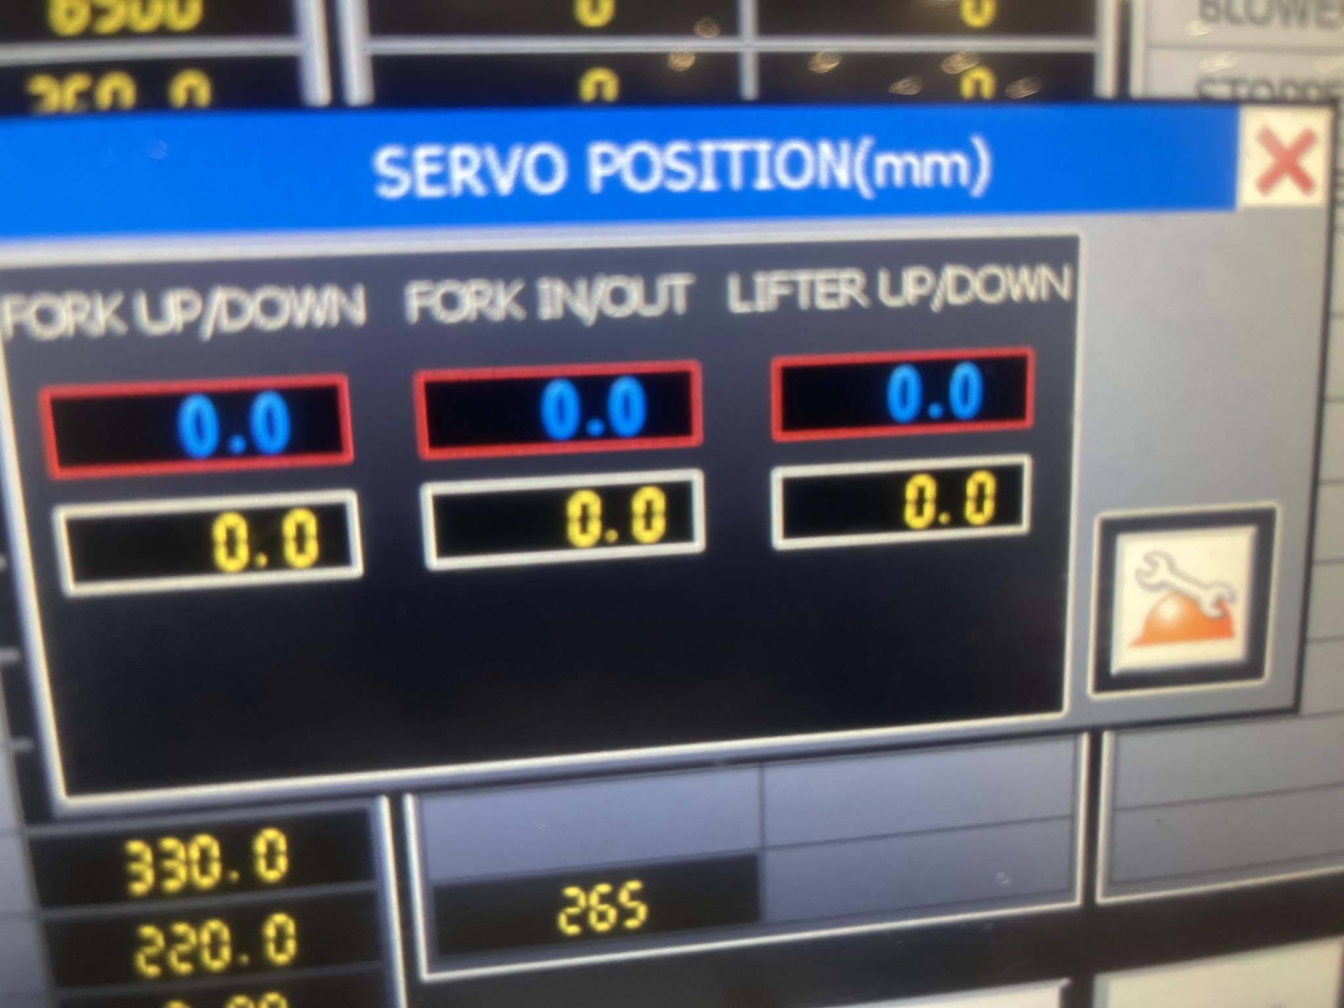
This servo position tab will take you to the picture above. From here you can Hit the Wrench on a hard hat icon. This will now ask if you want to reset these locations with a push of the button to zero or change those locations themselves. Most of the time we are setting it to zero and have our machine in position for this so we just ZERO it out here.

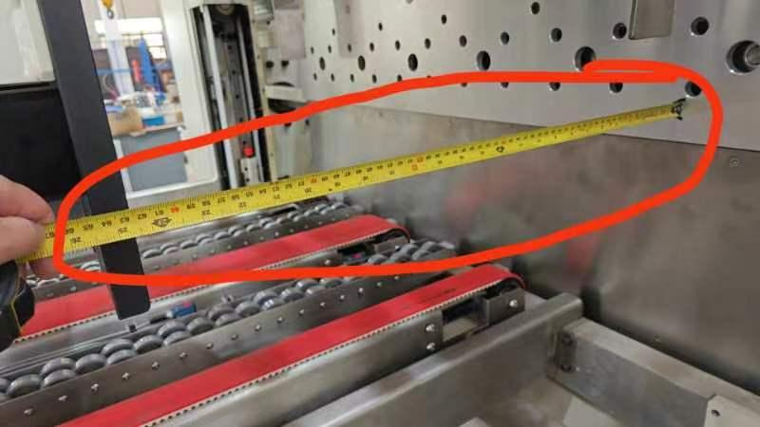
You must measure this location (COUNTER EJECTOR BACKSTOP) first when homing your counter ejector. This backstop position is also very important to the FORK IN AND OUT and its ERRORS. Always check the backstop dimension first and make sure it is correct on the HMI SCREEN. If it is not CALIBRATE IT correctly.

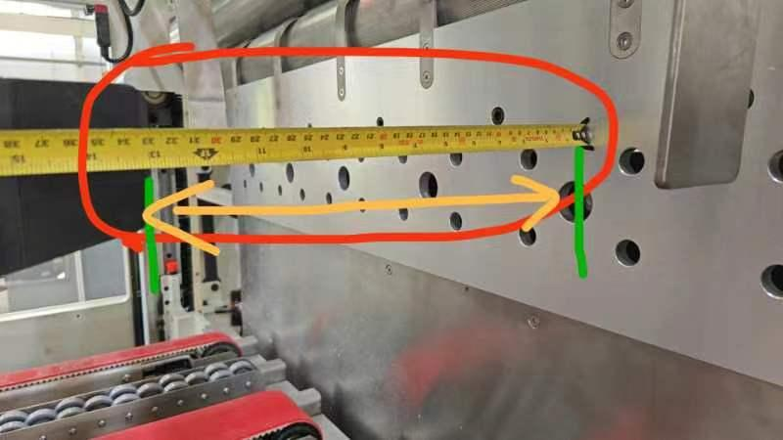
Next is measuring the distance from the pusher plate to the edge of the paper forks. This dimension is your forks in and out. If the backstop is set correctly and this number is entered correctly on the HMI SCREEN then you should not have any issues with FORK IN and OUT ERRORS.
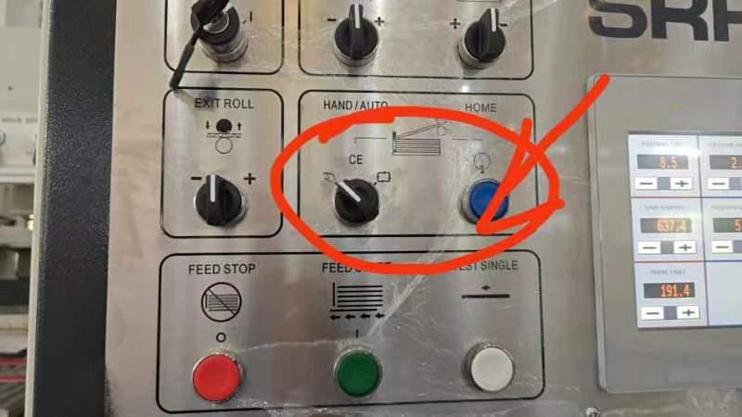
This switch puts the counter ejector section in manual mode allowing you to move it with the other switches located on the left side of this picture. The BLUE button or home button is also the reset button. Hitting that several times when the switch is turned to manual will do a soft reset on the current function.

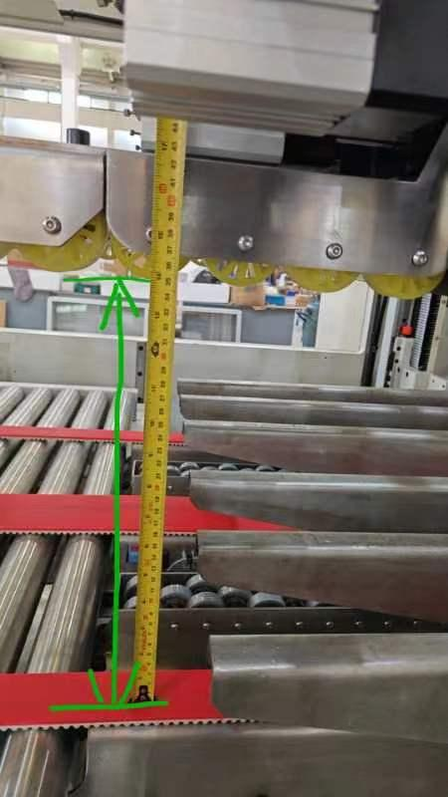
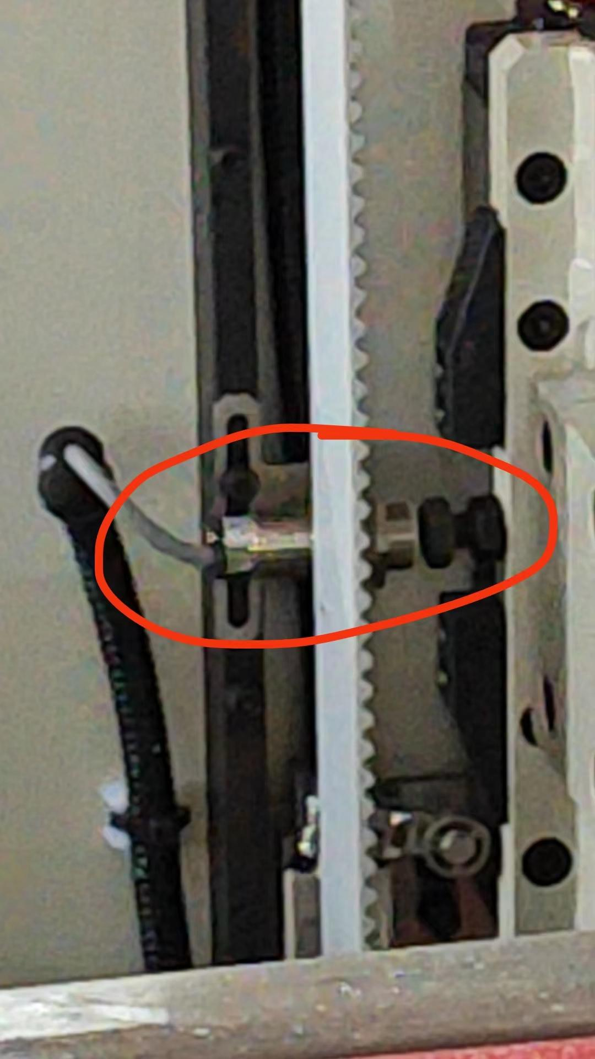
The bundle press is another location that needs to be exact when homing the counter ejector. Make sure that this number is correct and if not CALIBRATE it. If your forks are sticking up a little higher than the bundle press table, one of those dimensions could be off and it's usually this one. Correct it on the HMI and it should go back to where you need it to be.
The pictures above and below are the Proximity switches that need to be aligned when homing to zero. Make sure that all of these connections are tight and secure on a regular basis. Note the limit switch located right below as well.

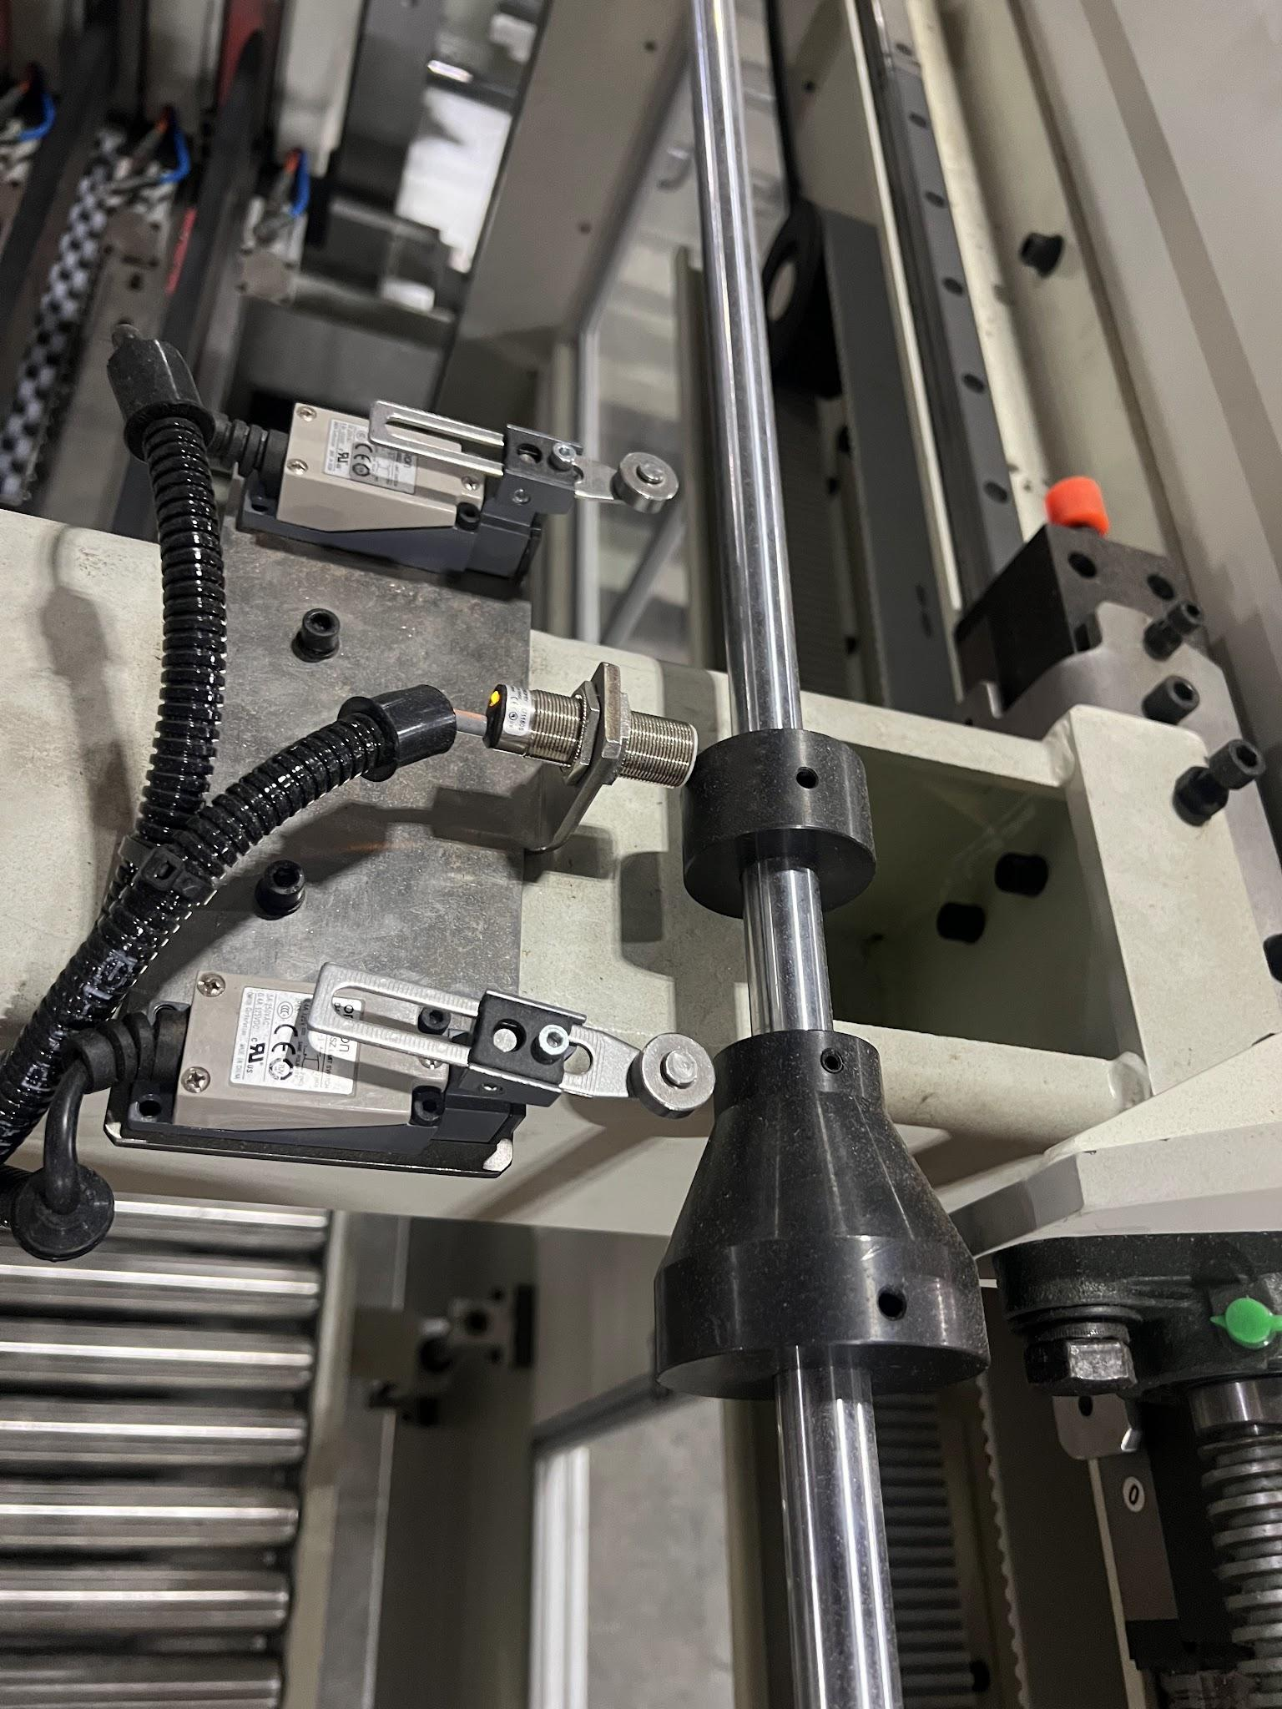
Same: Proximity sensors and limit switches on the operator side for the FORK IN and OUT.

