Standard Operating Procedure

1. Purpose
How to properly Clean the machine at the end of a shift or day. You can specific things you might want to do on specific days as well but this is a basic daily clean up of the machine. This will help prevent breakdown and unnecessary downtimes on the machine.

2. Scope
This is to be used by Thacker Machinery/SRPACK employees and/or any personnel that need to properly clean the machine daily and what should be looked at and maintained to help keep your SRPACK machine in top form.

3. Prerequisites
Tools Needed:
Rags or Paper towels to wipe down shafts and excess oils and grease.
Air Hose
Food Grade Silicone
Soap and water
an empty 5 gallon bucket for every print station

4. Procedure
- First stop the machine from moving.
- Go to the Die Cutter Section and open the Die Cutter Gap to max. You never want to leave your die cutter gap crushing. It will ruin your dies and your mats and your machine.
- Open the machine up manually.
- You should open the Die Cutter Section, the Slotter Section (if your machine has one), any print section that you have been using that day front and back, and the section between the feeder and the first print section.
- One person can begin in the Feed Section of the machine while another can start at the rear of the machine in the Counter Ejector. There is no true order, just things that need to be done.

- FEED SECTION:
  - Blow out area: pay special attention in the feed table between the rollers, the ball screw shafts and all of the linear bearings and slides that they roll on.
  - Lubricate table areas that are stainless, feed gates and sides, linears ball screws and slides, ball screws and any other area up front that may need FOOD GRADE SILICONE. DO NOT get this on the feed wheels, if you do, you can clean them with a little denatured alcohol.
  - Wipe excess silicone with RAGS or Paper towel so that there is not build up on these parts. This needs to be daily to ensure that there is no build up.
  - Lubricate the backstop and make sure the angle bolts are tightened and everything is secure
- PRINTER SECTION:
  - Blow out area: pay special attention in the feed table between the rollers. Clean out any corrugated board caught in the table.
  - Clean Print Die and remove ink so that it does not dry on it overnight.
  - Clean any ink off the print cylinder.
  - Return your ink, do at least 1 washout on the machine, return back to the ink supply and let SOAP AND WATER run through the ink chamber for 5-10 mins (This is where you need the empty 5 Gallon buckets).
  - When this is done, go through the cycle again. Ink return, Washup, and then you can ink return and then STOP.
  - Clean any excess ink, grease, or oil in the machine.
  - Check ink pans to ensure they are being cleaned by the soap and water clean ups and if not you will need to remove these and clean them or clean them in place. Excessive build up causes low ink alarms and other issues to occur in the machine.
  - Turn off Anilox Roll.
  - Open Ink Chamber and wipe clean
  - Check the wiper blade, check end seals if your model has those

- Slotter Section: (If your machine has one)
  - Blow out area: pay special attention to the ball screw shafts and all of the linear bearings and slides that they roll on.
  - Make sure the area is clear of debris and ink. (if there is ink on these shafts then you have other issues in the machine with your printers. Clean all of this off the shafts.
  - Lubricate stainless steel shafts, linears ball screws and slides, and ball screws. FOOD GRADE SILICONE. DO NOT get this on the crush wheels or creaser wheels, if you do, you can clean them with a little denatured alcohol.
  - Wipe excess silicone with RAGS or Paper towel so that there is not build up on these parts. This needs to be daily to ensure that there is no build up. Both lubricating and wiping down.
- DIE CUTTER SECTION:
  - Blow out area: Clear all excess debris and material
  - Clean all the area, the die cutter floor and scrap conveyors.
  - Wipe the Pull Rolls Shafts, lubricate, and wipe excess.
- RAIL SECTION: (If your machine is a FFG)
  - Blow out area: pay special attention between the gang rollers and all of the belts. The area after the die cutter and where all the excess scrap travels on the rails tracks need to be blown out and cleaned as well.
  - Make sure that all sensors are secure and in place. Sometimes during jam ups we may not see sensors that have moved out of place throughout the day or days.
  - Every other day you can take a rag with the silicone on it and wipe the rails that the boxes slide down.
  - Wipe and clean all shafts. Lubricate the stainless steel shafts with FOOD GRADE SILICONE.
  - Wipe excess silicone with RAGS or Paper towel so that there is not build up on these parts. This needs to be daily to ensure that there is no build up on these shafts and your rails will slide freely as they should.
  - Clean the glue : Shut it down (see SOP for cleaning the glue)
  - Check the machine counter and make sure it is in position and clean the lens.

- COUNTER EJECTOR: (if your machine is a FFG)
  - Blow out area: Make sure the area is clear of bad boxes, torn paper or dirty sensors.
  - Clean excess glue off any rollers.
  - Check gearbox oil levels.
  - Check Chains for lubrication and to make sure they are tight. Lubricate if necessary. Ask maintenance to tighten chains if necessary.

5. Definitions and Pictures
Front End of SRPACK Machine:  The Feed Section is very important on this machine and must be well maintained. Check the gearbox oil levels regularly. Blow out and lubricate the machine daily. Keep the ball screws clean and your stainless well lubricated. | 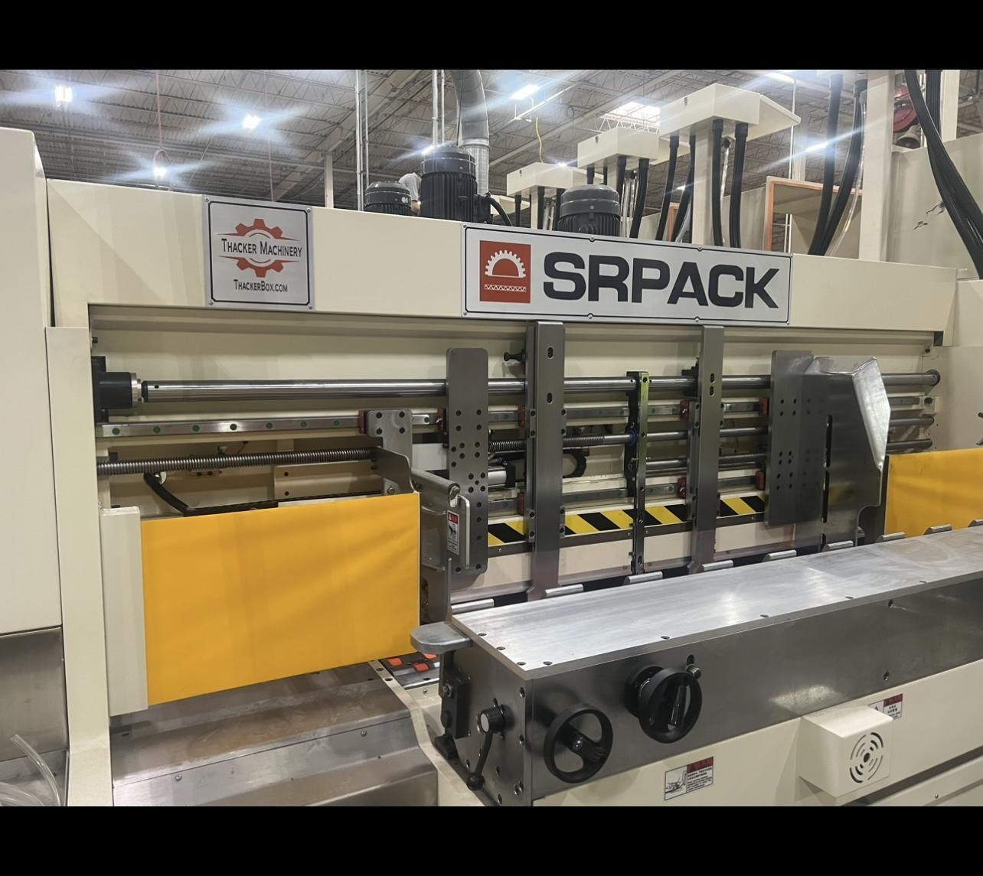
The Printer Section needs to be cleaned to keep working every day all day. Getting ink throughout the machine is never a good thing and we have to work daily in order to prevent the bigger problems from happening. Daily clean up and maintaining this area will ensure that you can have good set up times and minimal issues with your print sections. | 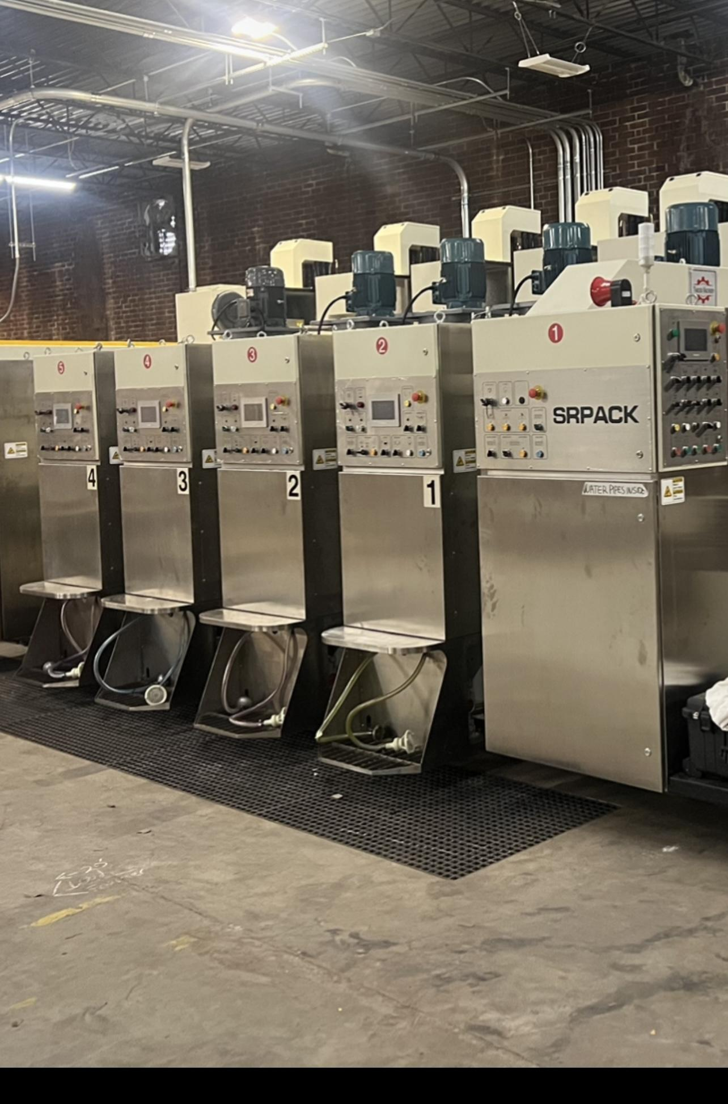
The Slotter Section (if your machine has one) is very important to blow out, wipe down, and lubricant daily. This has 5 head sections with 4 main components on each one. Keeping these clean causes less binding in the shafts and allows for free movement of the slotter heads. Clean all shafts and ball screw shafts and lubricate with FOOD GRADE SILICONE and wipe | 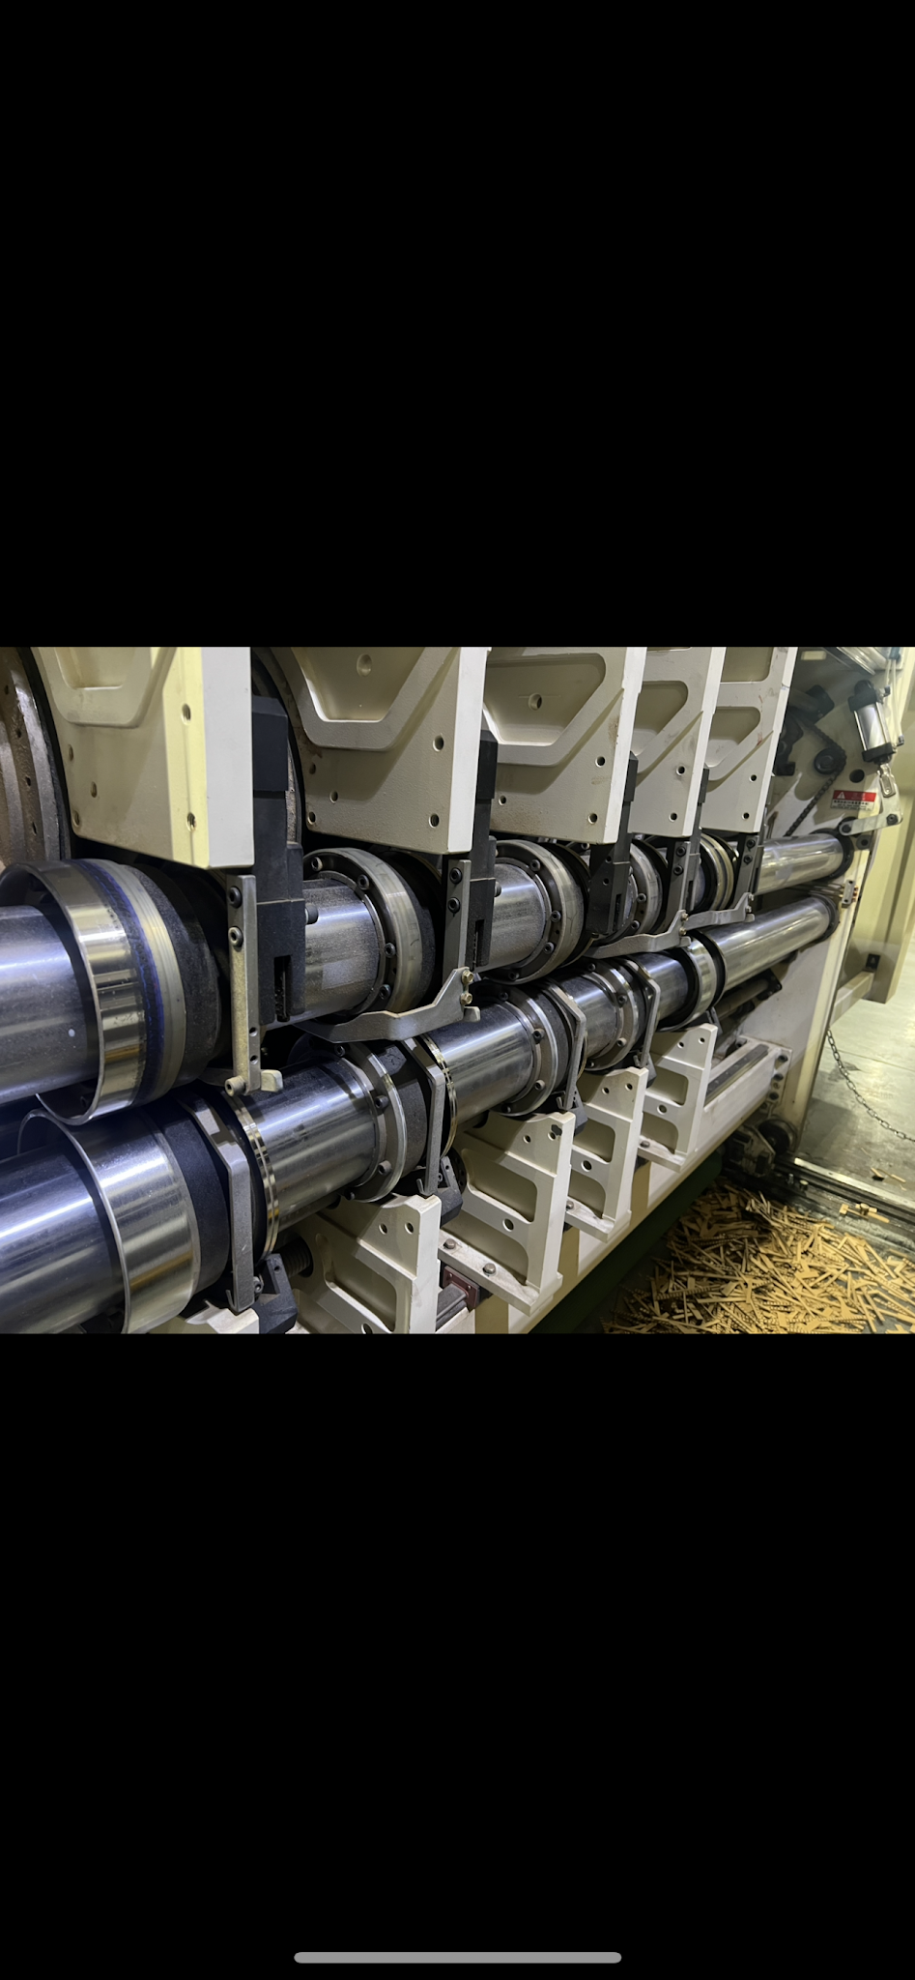
The Rail Section (FFG MACHINES)  This section's shafts and other moving parts are very important to keep clean. Gears, shafts, and slides should be wiped down and lubricated daily. Excess corrugated needs to be removed and all ball screws should be cleaned. Make sure that all gang rollers are tight and in place as well. Machine vibration causes nuts to come free and these may move over time.  Check belts for wear and lacing.  Check belts and drives. | 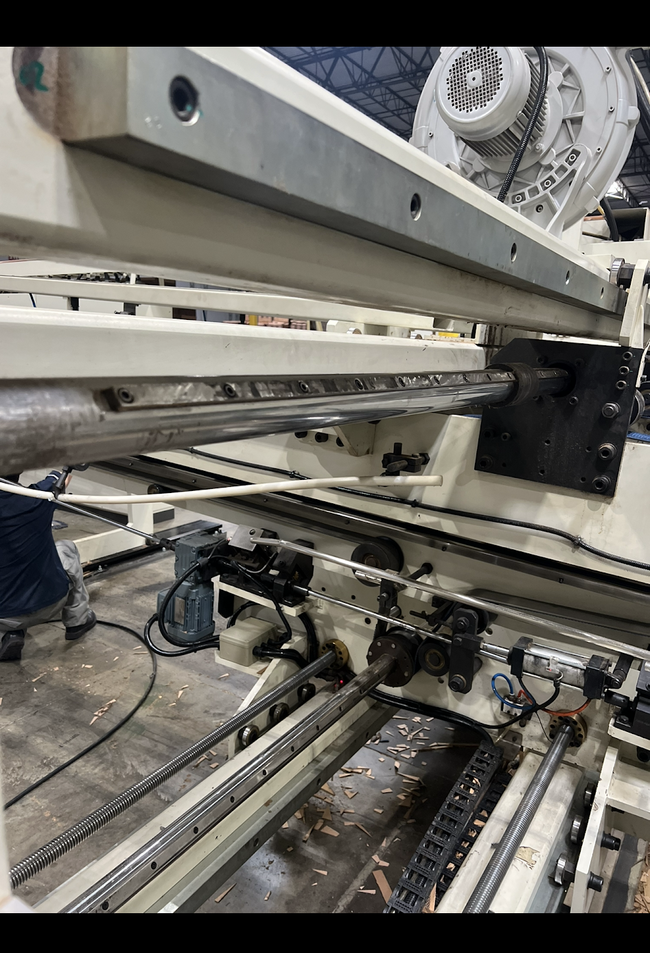
Counter Ejector Section (FFG)  Making sure this section is blown out, chains are tightened and lubricated, and all sensors are clean and clear are the main things for cleaning up daily in the counter ejector.  Clean any excess glue or ink off the counter ejector pull roll. Again, if you are getting these types of build ups then you should look at the glue and the ink situation and see what needs to be adjusted.  Clean all sensors and clear counter ejector bundle press of any boxes.  Double check the box counter position. | 