Standard Operating Procedure

1. Purpose
How to properly calibrate the Front-End Backstop. This procedure will be used in the Feed Section in the front of the machine. This will help you put your backstop to the desired measurement and tell the machine exactly where the backstop is at. This should help going forward making all future set-ups easier.

2. Scope
This is to be used by Thacker Machinery/SRPACK employees and/or any personnel that need the proper way to calibrate the Front-End Backstop.

3. Prerequisites
Tools Needed: Tape measure or known size of corrugated board. You do need the admin password to get into the front LCD and calibrate the machine.
Machine must have power and be operational to perform.
Password: 12345

4. Procedure
- Stop the Machine and make sure there is nothing in the hopper of the front feed section.
- On the Front Feed Section Panel, use the Backstop switch to move the Backstop to the desired position. Make sure this position is correct with your personal tape measure or a corrugated board that you know the measurements of.
- On the LCD Panel on the Front Feed Section Panel got to L2.
- Now click on the Orange written number for the Backstop. This will be the numbers above the yellow numbers. (the “set” numbers)
- When you click on those numbers there will be a password screen pop up.
- Enter in Password: 12345
- This will take you back to the L2 screen however the Backstop numbers will be highlighted in blue. Click on this again.
- Another numeric screen will pop up and this is where you put the actual dimension that you have the backstop at.
- Hit enter and this will exit you back to the L2 screen once again with the backstop number being changed.

5. Definitions and Pictures
Front End Backstop:  The front-end backstop provides support for the corrugated material in the hopper. Making sure this section is correctly calibrated helps for faster and more accurate set ups and operation of the machine. Along with Housekeeping and keeping this area lubricated, Calibration is also very important. | 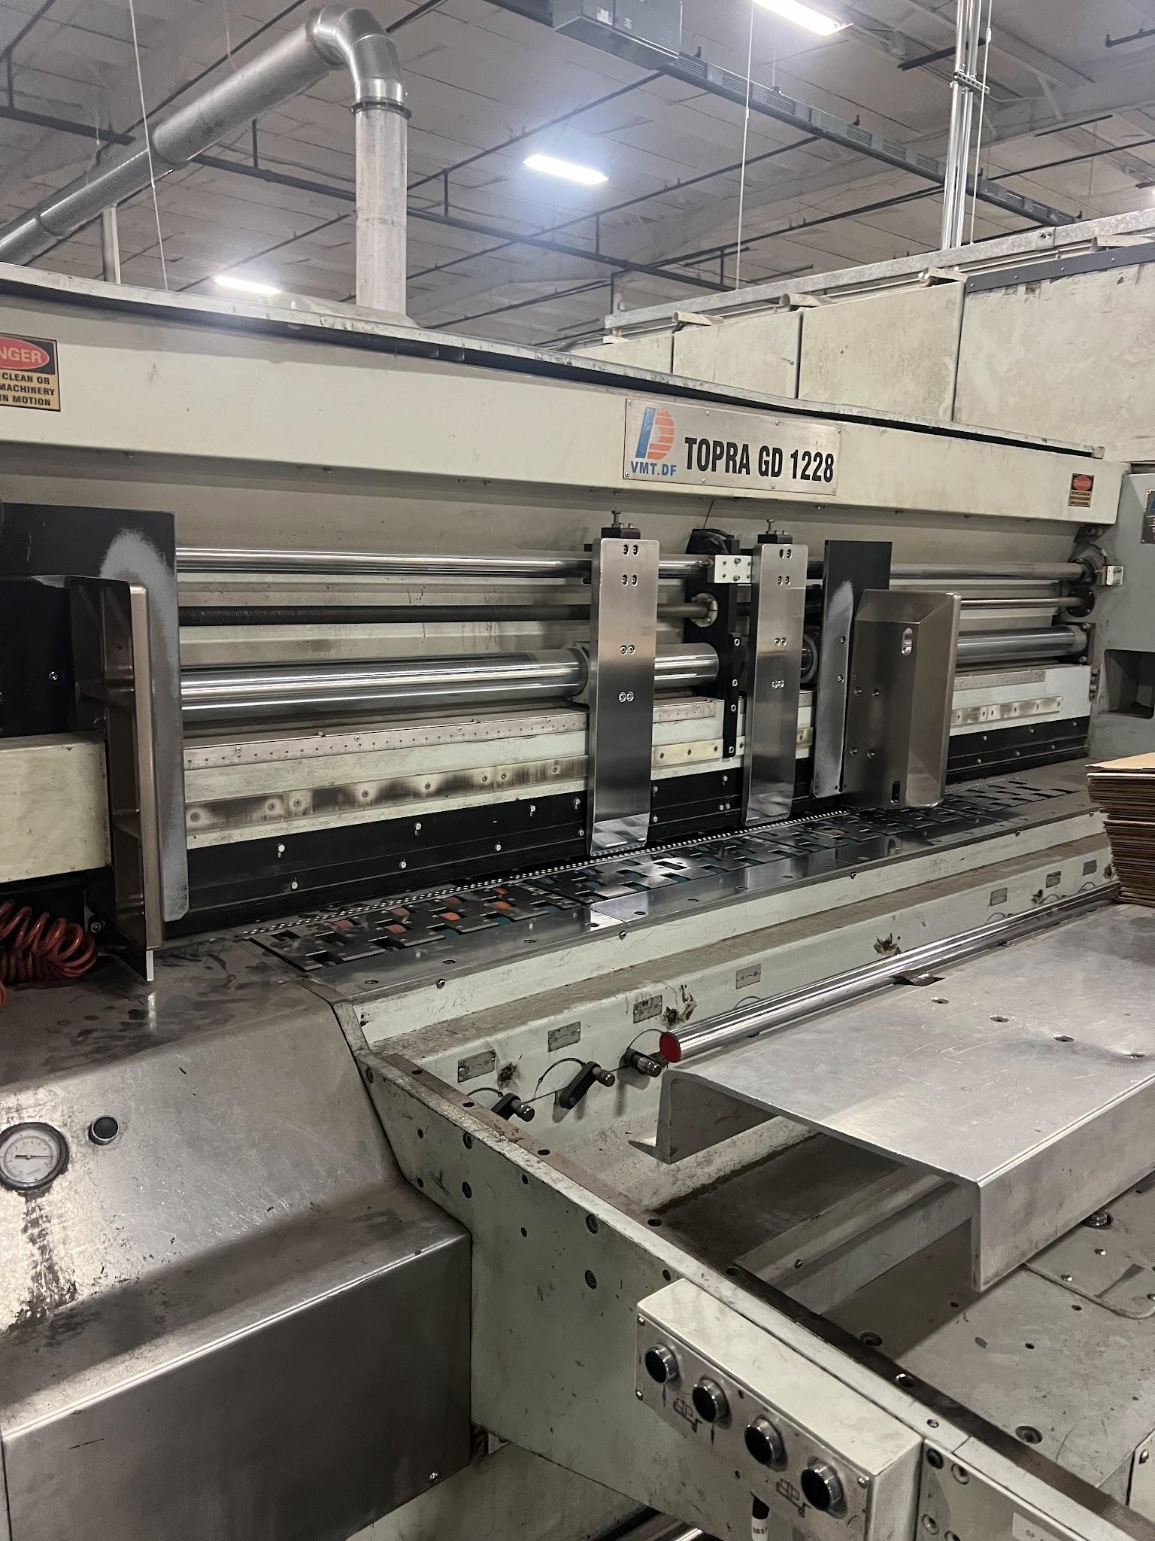
Backstop Switch and LCD:  On the Front Feed Section Panel there is a switch labeled BACKSTOP. (ENDSTOP) | 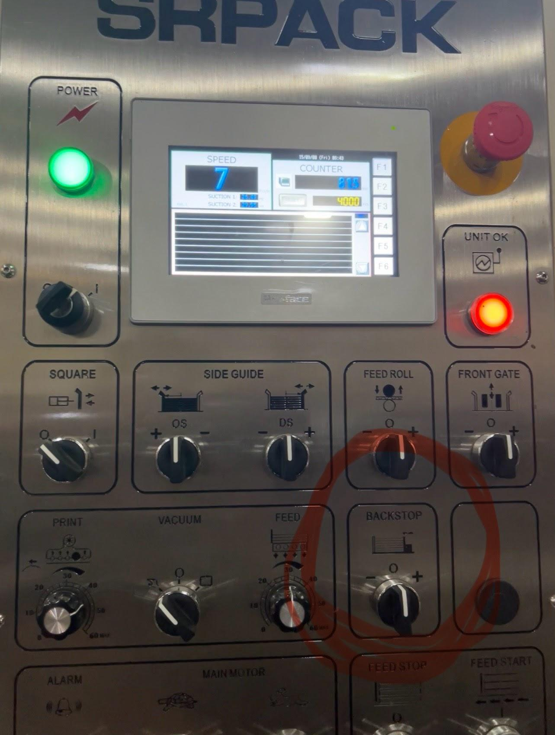
From this picture you can also see the orange and yellow numbers. The orange being the “ACTUAL” measurement the part is at and the yellow being the number the machine was to “SET UP” at. The Backstop (ENDSTOP) is in the lower right corner. | 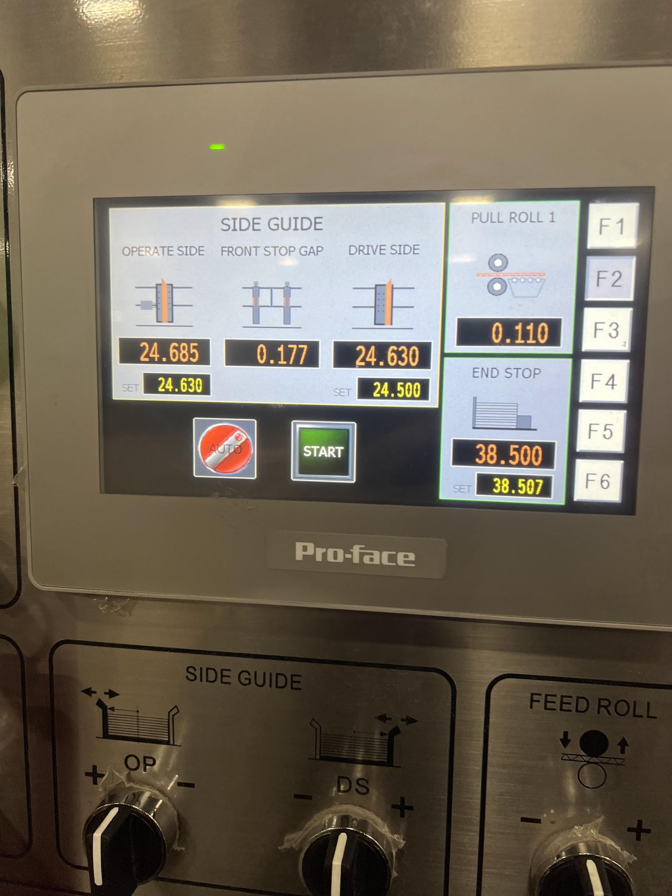
PASSWORD SCREEN:  When you press onto the orange number for the Backstop (ENDSTOP) on L2 of the LCD panel, this is the password screen that will come up. Enter 12345.  Hit Enter and it will take you back to the L2 screen with the same drive side operator number being highlighted in blue. | 